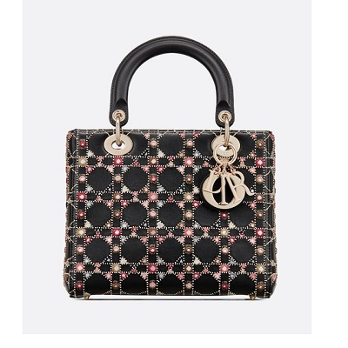

Lady Dior embroidered bag

PRODUCT DETAILS

**Jewelry in light gold-tone metal**

**Carried in the hand, on the shoulder or across the body**

**Dimensions: 24 x 20 x 11 cm**